

DriverPass Business Requirements Document

Alexis Prazak
Southern New Hampshire University
CS255: System Analysis and Design
Goran Trajkovski
November 26, 2023

System Components and Design

Purpose

The goal of DriverPass is to help users practice for their driving test. There is a current gap in the market when it comes to tools of this nature, causing many people to fail their DMV tests. The key functions of this system will allow customers to access practice exams and book driving lessons from their desktop or mobile devices. They can also view personalized feedback from their driving instructor. DriverPass staff can use the system to manage customer relationships.

System Background

- The system should assist the user in studying for their driving exam by providing practice exams and feedback. This information should accurately reflect current DMV regulations.
- DriverPass wants the user to be able to book driving lessons online. Accounts will be needed for each user.
- The system will consist of a user interface for DriverPass's users.
- The system will give the owner and IT administrator accounts special privileges. It will allow these accounts to manage data and other accounts.
- System information should be stored securely in the cloud.

Objectives and Goals
- To accomplish their task DriverPass needs specific features.
  - Provide the user with the ability to take practice exams and get feedback on their responses.
  - Allow users to book driving appointments and purchase lesson plans online.
  - Create a user interface that is easy for the client and their customers to use.

Requirements

Nonfunctional Requirements

Performance Requirements
What environments (web-based, application, etc.) does this system need to run in? How fast should the system run? How often should the system be updated?
- The system will run in a web-based environment.
- The service should run and store data in a cloud based system.
- The system should update the web-page in under five seconds.
- The system will provide feedback to user if updates go over the allotted time.
- System updates should happen as needed. This ensures it doesn't wait for key updates.

Platform Constraints
What platforms (Windows, Unix, etc.) should the system run on? Does the back end require any tools, such as a database, to support this application?
- The system should support devices on the following platforms:
  - Windows
  - Linux
  - MacOS
  - Android
  - iOS
- Data will be stored in a cloud based storage system.
- The database will contain user records.

Accuracy and Precision
How will you distinguish between different users? Is the input case-sensitive? When should the system inform the admin of a problem?
- Users will be required to login into the system at the beginning of each sessions. This will allow DriverPass to differentiate between different user types.
- To prevent unauthorized account access usernames and passwords will be case-sensitive.

Adaptability
Can you make changes to the user (add/remove/modify) without changing code? How will the system adapt to platform updates? What type of access does the IT admin need?
- The IT admin and business owner will have special access to modify accounts.
- The IT admin will be allowed to make modifications to the system.
- The system will allow the owner to toggle the ability to purchase packages on and off.
- The system may need a developer to add or significantly change features.

Security

- Users will login using the email and password associated with their account. Passwords should require a minimum of eight characters and a combination of letters, numbers, and special characters.
- After three login attempts the system will require the password to be reset. The account will remain locked until that is done.
- Users can reset their password using the email associated with their account. This is email is sent after three failed login attempts or upon request.
- The data will be sent over an encrypted connection.

Functional Requirements
Using the information from the scenario, think about the different functions the system needs to provide. Each of your bullets should start with “The system shall . . .” For example, one functional requirement might be, “The system shall validate user credentials when logging in.”
- The system shall prompt users to login or create an account when making a purchase or setting an appointment. System must confirm with account records that a valid username and password is entered.
- The system shall connect to the DMV to have the most current regulations.
- The system shall allow students to view study materials based on the package purchased.
- The system shall track user activity. It will be stored in a downloadable report.
- The system shall allow the owner to turn off the ability to purchase certain packages.
- The system shall have an interface for each type of user.
- The system shall display driver notes.
- The system shall let the students purchase packages online or through the secretary.
- The system shall let users make and modify reservations.
- The system shall allow access from internet connected devices 24/7.

User Interface
What are the needs of the interface? Who are the different users for this interface? What will each user need to be able to do through the interface? How will the user interact with the interface (mobile, browser, etc.)?
- DriverPass will need to automatically resize the interface based on the type of device being used.
- All types of users will have an easy to understand interface they can interact with. Each user will see the following:
  - Student: They will be able to see their study materials, profile information, test progress, and instructor notes.
  - Driver: They will see a list of their appoints and have a chart where they can input notes about students.
  - IT Administrator: They will be able to view activity, download it, reset accounts, and modify the system.
  - Secretary: They will be able to create user accounts and manage appointments.
  - Owner: The owner should be able to see the notes and activity from all users. They will also have the ability to modify and block accounts.
- The client drew an image of how he wanted the customer's page to look.
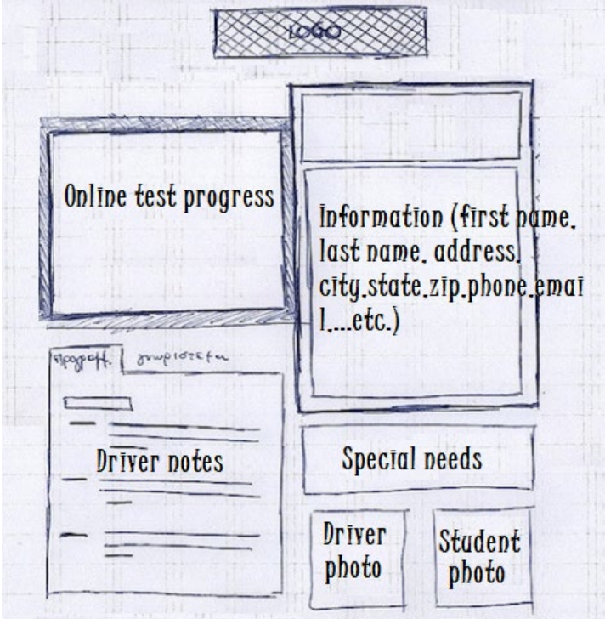

Assumptions
What things were not specifically addressed in your design above? What assumptions are you making in your design about the users or the technology they have?
- We assume all users will have an email account. This will be used to verify the user and reset an account's password.
- We assume users will have an email they can use to verify account activity. It's also assumed they can also use this email to receive order and appointment confirmations.
- We assume all users will have an internet connected device.
- We assume users will be familiar with navigating websites and making purchases online.

Limitations

- We are projecting the project will be complete by May 10th.
- Customer and vehicle records are currently kept on another system. Data will need to be transferred to a cloud storage system.
- DriverPass has a limited number of cars. The system should allow the client to limit the number of appointments customers can make for a given time slot.
- The company does not have a developer on staff. Outside help may be required to make significant changes to the system.

Gantt Chart

